ER Mesh Generation Tutorial: Two Buried Blocks

Conceptual Diagram
In this example, we build a mesh comprising surface electrodes, two subsurface boxes, a foreground zone defined for convenient visualization, and a boundary zone that extends from the foreground zone to the external boundaries. The jupyter notebook two_blocks_ERT1.ipynb takes the user through the steps in this tutorial. The file clear_files.ipynb resets the directory to contain files before running two_blocks_ERT1.ipyn. The directory named visit contains the xdmf files created using px, and electrode locations for visualization.
A conceptual diagram of the mesh, including control points and zone assignments to be defined in the mesh configuration file, is shown in Figure 1. The mesh consists of three lines of surface electrodes, where line 1 includes control points 1 through 16, line 2 includes control points 17 through 32, and line 3 includes control points 33 through 48. Control points 49 through 52 and 57 through 60 define the foreground region, which is assigned to be zone 1. Control points 61 through 68 define the western-most box, which is assigned to be zone 2. Control points 69 through 76 define the eastern-most box, which is assigned to be zone 3. The region extending from the foreground to the outer boundaries is not shown, but is assigned to be zone 4. The mesh configuration file for Figure 1 (two_blocks.cfg) is shown below with annotations denoting the corresponding mesh configuration file variables described above
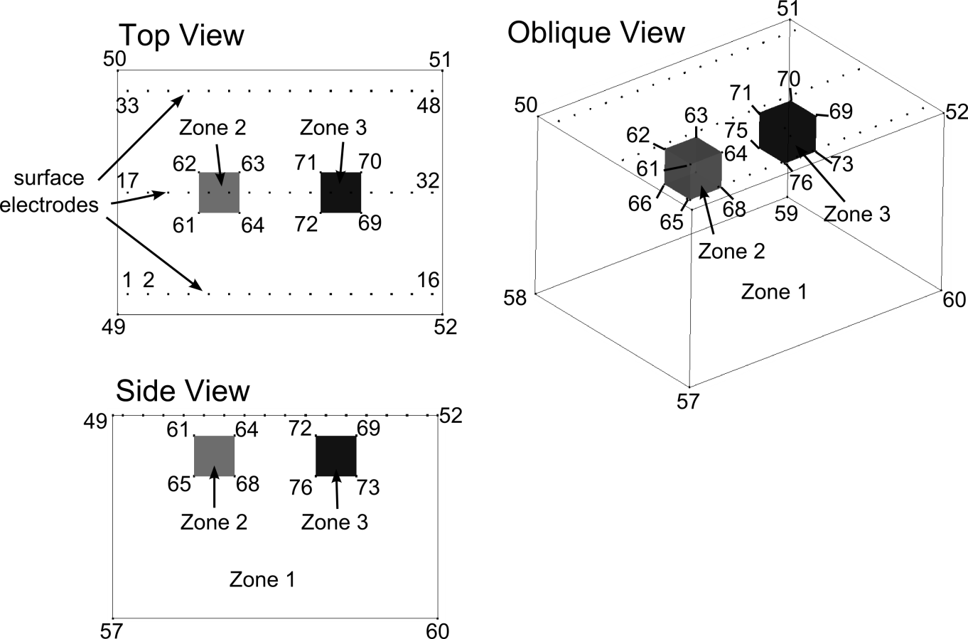
Figure 1. Control point and zone map for mesh configuration file two_blocks.cfg. External boundary points 54-56 and internal refine points 77-124 are not shown. The part of the domain extending from zone 1 to the external boundaries (zone 4) is also not shown.

Building the Mesh
In addition to the mesh configuration file, the run configuration file e4d.inp is needed to build the mesh. In mode ERT1, the only file that must be listed is the mesh configuration file. The run configuration file for this example is shown below.
<begin run configuration file e4d.inp> (this line is not included in the file)
ERT1
two_blocks.cfg
<end run configuration file e4d.inp> (this line is not included in the file)
To build the mesh, execute the command:
<e4d_dir>/bin/mpirun -np 1 <e4d_dir>/bin/e4d
or
mpirun -np 1 e4d
if <e4d_dir>/bin is in the executable path, where <e4d_dir> is the E4D installation directory. E4D builds the input files for triangle and tetgen, and calls each to build the mesh. E4D then builds a conductivity file for the mesh as specified in the mesh configuration file, and calls px to build a file for visualization. The files generated include:
File | Generated by | Description
two_blocks.poly | e4d | Tetgen input file generated by E4D. Not used in run modes > 1.
two_blocks.1.node | tetgen | Tetgen node file. Gives the nodal coords of the mesh.
two_blocks.1.ele | tetgen | Tetgen element file. Describes how nodes are connected to form elements.
two_blocks.1.face | tetgen | Tetgen face file. Describes which nodes form boundary faces.
two_blocks.1.neigh | tetgen | Tetgen neighbor file. Provides neighbors of all elements.
two_blocks.sig | e4d | Conductivity file. Describes element conductivities and is written to the exodus file.
two_blocks.xmf  two_blocks.h5 | px | Xdmf files used to visualize mesh and conductivity distribution.
two_blocks.exo | bx | Exodus file used to visualize mesh and conductivity distribution.

Two_Block Mesh Visualization
Figure 2 shows a visualization of the mesh produced using VisIt with the exodus file two_blocks.xmf.
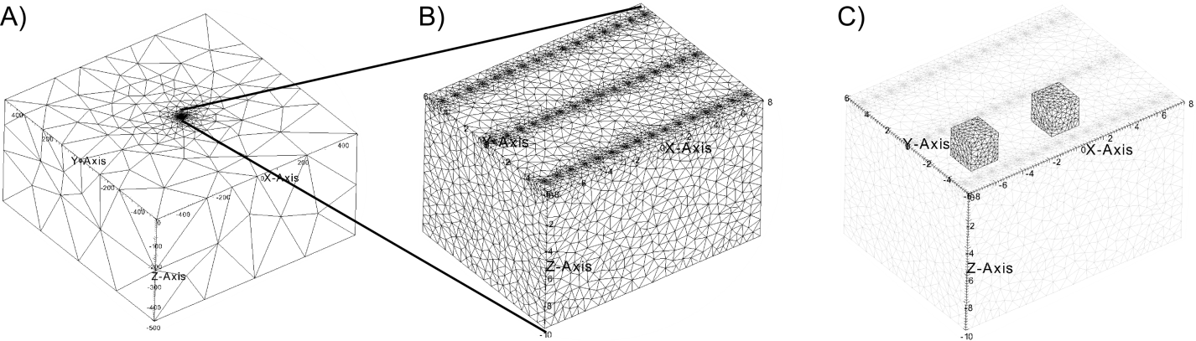
Figure 2. A) Oblique view of mesh show outer boundaries of zone 4 and inner refined region comprising the electrodes and box bounded by zone 1. B) Oblique view showing other boundaries of zone 1 and mesh refinement at electrode locations. C) Oblique view with zone 1 boundaries shown in transparency to reveal zone 2 and zone 3 boundaries.

Mesh Configuration File: two_blocks.cfg

<begin file two_blocks.cfg> this line is not included in two_blocks.cfg

1.3 1e12 mesh quality (m_qual) max volume (max_evol_def)
-500 bottom of mesh elevation (m_bot)
1 flag to build mesh (tet_build_flag)
"tetgen" command to run tetgen (tet_loc)
"triangle" command to run triangle (tri_loc)
124 number of control points (n_cpts)
1 -7.5 -5 0 1 1 x1 y1 z1 b_flag_1
2 -6.5 -5 0 1 2 x2 y2 z2 b_flag_2
3 -5.5 -5 0 1 .
4 -4.5 -5 0 1 .
5 -3.5 -5 0 1 .
6 -2.5 -5 0 1
7 -1.5 -5 0 1
8 -0.5 -5 0 1
9 0.5 -5 0 1
10 1.5 -5 0 1
11 2.5 -5 0 1
12 3.5 -5 0 1
13 4.5 -5 0 1
14 5.5 -5 0 1
15 6.5 -5 0 1
16 7.5 -5 0 1
17 -7.5 0 0 1
18 -6.5 0 0 1
19 -5.5 0 0 1
20 -4.5 0 0 1
21 -3.5 0 0 1
22 -2.5 0 0 1
23 -1.5 0 0 1
24 -0.5 0 0 1
25 0.5 0 0 1
26 1.5 0 0 1
27 2.5 0 0 1
28 3.5 0 0 1
29 4.5 0 0 1
30 5.5 0 0 1
31 6.5 0 0 1
32 7.5 0 0 1
33 -7.5 5 0 1
34 -6.5 5 0 1
35 -5.5 5 0 1
36 -4.5 5 0 1
37 -3.5 5 0 1
38 -2.5 5 0 1
39 -1.5 5 0 1
40 -0.5 5 0 1
41 0.5 5 0 1
42 1.5 5 0 1
43 2.5 5 0 1
44 3.5 5 0 1
45 4.5 5 0 1
46 5.5 5 0 1
47 6.5 5 0 1
48 7.5 5 0 1
49 -8 -6 0 1 upper control points for foreground (zone 1)
50 -8 6 0 1
51 8 6 0 1
52 8 -6 0 1
53 -500 -500 0 2 boundary control points
54 -500 500 0 2
55 500 500 0 2
56 500 -500 0 2
57 -8 -6 -10 0 lower control points for forground (zone 1)
58 -8 6 -10 0
59 8 6 -10 0
60 8 -6 -10 0
61 -4.0 -1.0 -1.0 0 Upper control points for left block (zone 2)
62 -4.0 1.0 -1.0 0
63 -2.0 1.0 -1.0 0
64 -2.0 -1.0 -1.0 0
65 -4.0 -1.0 -3.0 0 lower control points for left block (zone 2)
66 -4.0 1.0 -3.0 0
67 -2.0 1.0 -3.0 0
68 -2.0 -1.0 -3.0 0
69 4.0 -1.0 -1.0 0 upper control points for right block (zone 3)
70 4.0 1.0 -1.0 0
71 2.0 1.0 -1.0 0
72 2.0 -1.0 -1.0 0
73 4.0 -1.0 -3.0 0 lower control points for right block (zone 3)
74 4.0 1.0 -3.0 0
75 2.0 1.0 -3.0 0
76 2.0 -1.0 -3.0 0
77 -7.5 -5 -0.05 0 additional points for electrode refinement
78 -6.5 -5 -0.05 0
79 -5.5 -5 -0.05 0
80 -4.5 -5 -0.05 0
81 -3.5 -5 -0.05 0
82 -2.5 -5 -0.05 0
83 -1.5 -5 -0.05 0
84 -0.5 -5 -0.05 0
85 0.5 -5 -0.05 0
86 1.5 -5 -0.05 0
87 2.5 -5 -0.05 0
88 3.5 -5 -0.05 0
89 4.5 -5 -0.05 0
90 5.5 -5 -0.05 0
91 6.5 -5 -0.05 0
92 7.5 -5 -0.05 0
93 -7.5 0 -0.05 0
94 -6.5 0 -0.05 0
95 -5.5 0 -0.05 0
96 -4.5 0 -0.05 0
97 -3.5 0 -0.05 0
98 -2.5 0 -0.05 0
99 -1.5 0 -0.05 0
100 -0.5 0 -0.05 0
101 0.5 0 -0.05 0
102 1.5 0 -0.05 0
103 2.5 0 -0.05 0
104 3.5 0 -0.05 0
105 4.5 0 -0.05 0
106 5.5 0 -0.05 0
107 6.5 0 -0.05 0
108 7.5 0 -0.05 0
109 -7.5 5 -0.05 0
110 -6.5 5 -0.05 0
111 -5.5 5 -0.05 0
112 -4.5 5 -0.05 0
113 -3.5 5 -0.05 0
114 -2.5 5 -0.05 0
115 -1.5 5 -0.05 0
116 -0.5 5 -0.05 0
117 0.5 5 -0.05 0
118 1.5 5 -0.05 0
119 2.5 5 -0.05 0
120 3.5 5 -0.05 0
121 4.5 5 -0.05 0
122 5.5 5 -0.05 0
123 6.5 5 -0.05 0
124 7.5 5 -0.05 0
17 number of internal planes (n_plc)
4 10 number of points in plc 1 (np1), boundary number(b_num_1)
49 50 58 57 control points in plc 1: western boundary of zone 1
4 10 np2 b_num_2
50 51 59 58 control points in plc 2: northern boundary of zone 1
4 10 .
51 52 60 59 eastern boundary of zone 1
4 10 .
52 49 57 60 southern boundary of zone 1
4 10 .
57 58 59 60 bottom boundary of zone 1
4 11
61 62 66 65 western boundary of zone 2
4 11
62 63 67 66 northern boundary of zone 2
4 11
63 64 68 67 eastern boundary of zone 2
4 11
64 61 65 68 southern boundary of zone 2
4 11
61 62 63 64 upper boundary of zone 2
4 11
65 66 67 68 lower boundary of zone 2
4 12
69 70 74 73 eastern boundary of zone 2
4 12
70 71 75 74 northern boundary of zone 2
4 12
71 72 76 75 western boundary of zone 2
4 12
72 69 73 76 southern boundary of zone 2
4 12
69 70 71 72 upper boundary of zone 2
4 12
73 74 75 76 lower boundary of zone 2
0 number of holes(n_holes)
4 number of zones(n_zones)
1 0.0 0.0 -5.0 0.1 0.002 zone1 xz_1 yz_1 zz_1 mz_vol_1 cond_1
2 -2.5 0.0 -2.5 0.01 0.002 zone2 xz_2 yz_2 zz_2 mz_vol_2 cond_2
3 2.5 0.0 -2.5 0.01 0.002 .
4 0.0 0.0 -20.0 1e12 0.002 .
1 flag to build exodus file (bex_flag)
'px' command to build exodus file (bex_loc)

<end file two_blocks.cfg> this line is not included in two_blocks.cfg

